220801140

**E**

**X**

**.**

**NO :**

**DATE :**

06

06/04/2024

# TIME SERIES

**AIM :**

To implement and check Time Series in Python

**PROGRAM :**

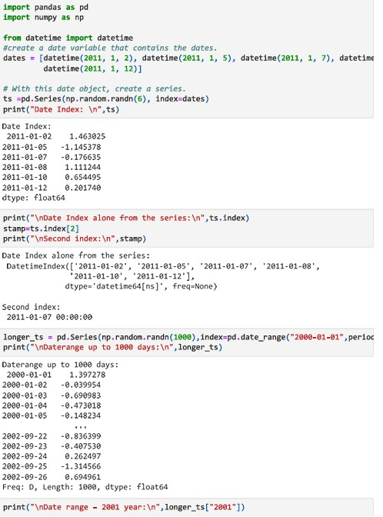

220801140

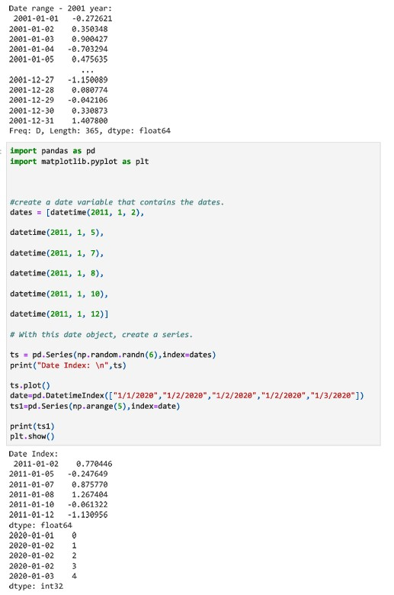

220801140

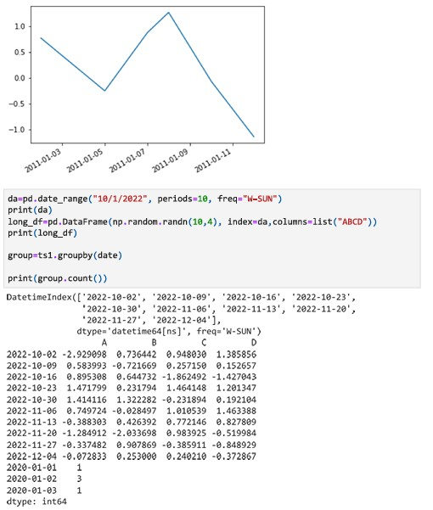

**Result:**

Hence the Time Series is implemented.